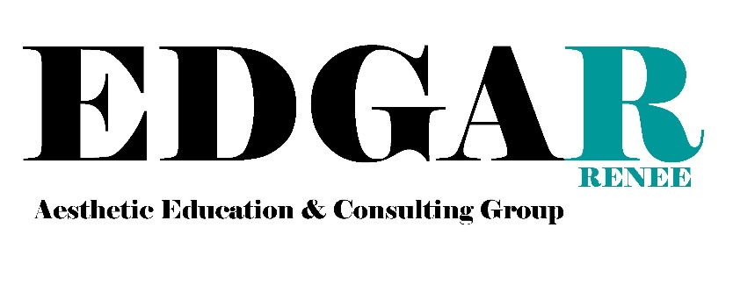
Model/Media Consent Form

I, _________________________________, hereby give my consent to all photographs, video recordings, and/or audio recordings taken of me by Edgarenee Aesthetic Education and Consulting Group and its affiliates. I understand that said photographs, video recordings, and audio recordings are the property of Edgarenee Aesthetic Education and Consulting Group and may be used for educational, instructional and promotional purposes. I also agree to take all treatment recommendations, product recommendations, and follow all regimens, that are suggested in lieu of payment. If at any time, Edgarenee Aesthetic and Education and Consulting Group sees that I am working against the treatment or not following the recommended treatment plan, they have the right to discontinue the treatments but still have the rights to the audio and video recordings and/or photographs.

Name:_____________________________________________Phone:_____________________

Signature:__________________________________________Date:_______________________

Witness:___________________________________________Date:_______________________

